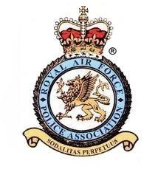
ROYAL AIR FORCE POLICE ASSOCIATION
Standing Order Mandate

Your Account Details:
Name of your bank:

Branch Address

Post Code

Account Number
Bank Sort Code

Name of Account

Standing Order Details – Please Pay
Royal Air Force Police Association 2 Account Number 91630878 Sort Code 01-05-02 NatWest Bank plc.
£12.50 | Amount in Words | Twelve pounds fifty pence
The Sum of

00 | 00 | 2019
Date of first Payment Thereafter annually on the first working day of January

<Insert membership Number, Initials, Surname >
Quoting Reference

Please cancel any existing Standing Order Mandates in favour of the Royal Air Force Police The Sum of £12.50 Association

Signature: ……………………………… Print Name: Date: __/__/____

Instructions for completion
- Please, please ensure that you enter your membership number, initials and surname in the box entitled
membership Number, Initials, Surname
Quoting Reference
- WHEN COMPLETE HAND THIS FORM TO YOUR BANK.

